Good Driving Habits
How to make every drop last longer
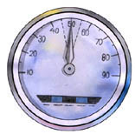 | Drive between 45-55 Km/H
 | Drive slow and steady. The faster you go, the more wind resistance your vehicle will face. If you go at speeds above 60 Km/H, you will waste petrol. Tests on Indian cars prove that you can get up to 40 % extra mileage at 45-55 Km/H as against 80 Km/H.
Remember
Avoid accelerating or decelerating unnecessarily.
Avoid banking by anticipating stops and curves well in advance.
Tests show that a reduction in speed leads to no appreciable rise in commuting time. Much less than what most people think.

Keep your engine healthy | 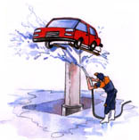
Tests on a large number of cars prove that you can save as much as 6% by tuning your car regularly. If your engine emits black smoke, has poor pulling power or consumes large quantities of oil, get it checked immediately at a reputed garage. A delay, may prove more expensive in terms of petrol and oil as compared to the cost of an overhaul.
Remember
Use of bi-metallic spark plugs saves over 1.5% fuel and reduces exhaust emissions too. Get your car serviced at every 5000 kms.

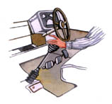 | Drive in the Correct Gear
 | Incorrect gear shifting can lead to as much as 20% increase in fuel consumption. Start your car in the 1st gear only, except if you are in a muddy patch or going downhill then engage the 2nd gear.
Remember
For city driving, change to a higher gear when you are sure the engine will not struggle. Get into top gear as soon as possible.
Use same gear for uphill and downhill journey.
It is advisable to follow the manufacturer's recommendation.
Top

Don’t wait for your car to warm up | 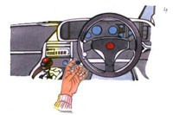
Instead, drive in low gear till the engine warms up. Use choke briefly only when necessary.
Remember
At 10°C and below, your fuel consumption per kilometer doubles when you make trips of 5 kms or less. So combine trips.
Do not park a car so that you have to reverse with a cold engine This will consume more fuel.
Install engine-heating system (in cold regions) in your car if it does not have one.

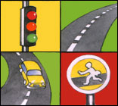 | Good Braking Habits
 | Stop-and-go driving wastes fuel. When you slam on the brakes, a lot of useful energy is wasted in the form of heat. A good driver always anticipates stops.
Remember
Test wheels for free rotation when your car is being serviced. Binding of brakes restricts free wheel movement and the engine consumes more petrol in order to overcome resistance.
Check wheel alignment at regular intervals.

Keep your Foot off the Clutch | 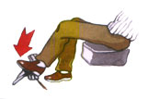
Use clutch only when you change gears. Riding the clutch causes loss of energy and damages clutch-linings.
Remember
Use your handbrake when stopped on an upgrade and don’t forget to release it when restarting.
Don’t manipulate the clutch and accelerator to stay stationary because it wastes fuel.
Top

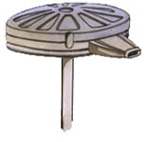 | Clean Air Filter Regularly
 | Air filter prevents dust from Fouling the engine. Dust causes rapid wear of engine components and increases fuel consumption.
Remember
Cylinder bores wear out 45 times faster in engines without air-cleaners
Clean air filters at every time-up.

Watch Your Tyre Pressure | 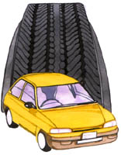
Under inflated tyres increase rolling resistance, which leads to higher petrol consumption.
Remember
Tests show that a 25% decrease in tyre pressure can cost you 5-10% more on petrol and 25% on tyre life.
Use radial tyres for 3-7% fuel economy, longer tyre life and greater riding comfort.

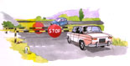 | When you stop your car, stop engine
 | Always keep your car ready to start. Keep the battery, dynamo, self-starter and fan-belt in good condition. This will ensure a quick start whenever you need it.
Remember
Switch off the engine at stops of over 2 minutes.
Top

Use the Recommended grade of oil | 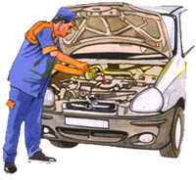
Check the car manual and oil manufacturer’s recommendations, before using any particular grade of oil. Always use multi-grade oil equivalent to SPCC/SGCC type for added benefits.
Remember
Engine oil that is thicker than the recommended oil can cause 2% increase in fuel consumption.
Change oil filter along with engine oil.

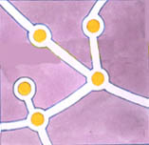 | Plan Your Route
 | Rush hour, or stop-and-go traffic, can waste fuel excessively. You will get more mileage from each litre if you take a less congested route, even though it is slightly longer.
Remember
Fuel consumption in a highly congested road can be double the normal.

Reduce Loads | 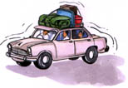
Unnecessary loads increase fuel consumption. Do you really need to carry the luggage rack?
Remember
A reduction of weight by 50 kg can lead up to 2% saving in fuel, when driving in the city. Remember that overhead racks increase wind resistance leading to higher fuel consumption.
Top

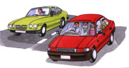 | Share Your car-for car pools
 | Look for people who go in the same direction as you. You can share your car and the costs.

Plan Your Trips | 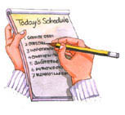
Before you start on a trip, ask yourself two questions:
Is this trip really essential?
Can I combine this trip with other trips in the same direction?
- Top

Make Gas & Kerosene last longer
Do you know that housewives can save upto 30% of cooking gas or kerosene by following a few simple ‘fuel–saving tips’?
We at PCRA have conducted a series of experiments on how to save cooking gas or kerosene. This was done in collaboration with the Indian Oil Corporation Ltd. (R&D Center), and the Institute of Hotel Management and Catering & Applied Nutrition, NEW Delhi. Our experiments have revealed that it is possible to save upto 30% of cooking gas or kerosene by following good cooking practices. It will be surprising to discover that certain cooking habits cause substantial waste of fuel.
Given below are a few tips on how to minimize losses and get value for the money you spend on cooking gas or kerosene:-

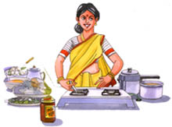 | A few minutes of planning ensures a big fuel saving
 | Every thrifty you can avoid an idle flame if you prepare and keep all materials required for cooking within reach, before lighting the stove. Experiments have revealed that keeping the flame of the larger burner burning unnecessarily in a gas stove, results Even a few paise saved everyday will amount to a sizeable saving by the end of a month.
Remember
Light your stove only after you have kept all the ingredients within your reach and ready for cooking. Put off an idle flame at once.

Pressure cooking saves fuel | 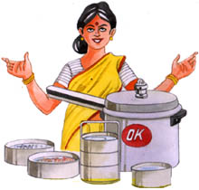
Pressure cooking is one of the fastest and most economical ways of cooking. Experiments have shown fuel (kerosene or cooking gas) savings of 20% on rice, 46% on soaked gram dal and 41.5% on meat, as compared to ordinary cooking. The savings in cooking time were equally high. To obtain further savings from a pressure cooker, use the separators of the cooker to cook different items such as rice, vegetable and dal, all at the same time. Just think of the fuel and money you will save! And have your entire meal ready quickly.
Remember
Pressure cooking saves duel and time. Use separators in the pressure cooker to cook different items at the same time.

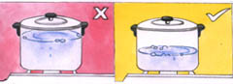 | Use optimum quantity of water
 | The quantity of water used differs for various dishes. And even for the same dish, different housewives use varying quantities of water. Since water is extensively used in cooking, you should remember that surplus water wastes fuel. Besides, when the excess water is drained subsequently, precious nutrients are lost. An experiment on cooking rice with double the required quantity of water has revealed that fuel consumption increased by 65% So use only the optimum quantity of water for cooking.
Remember
Surplus water consumes additional fuel which could otherwise be saved.

Reduce the flame when boiling starts | 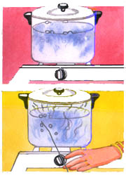
When a vessel’s contents reach boiling point, a low flame is enough to keep them boiling. Addition of more heat at the boiling stage causes further evaporation of the liquid without serving any useful purpose. Hence, when water or any other liquid is boiling, reduction in the flame will reduce wastage. This is possible in a gas stove by turning the know to ‘simmer’ position or in a kerosene stove by lowering the wicks. Experiments conducted have revealed a saving of 25% fuel when the flame was reduced after boiling had started. Try it yourself. You will find that the time taken to cook is just the same.
Remember
Always reduce the flame once boiling starts.

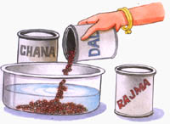 | Soak before cooking
 | Experiments have shown that soaking ingredients such as dal and rice for various intervals of time before cooking saves fuel. 250 gms of kabuli chana (chick peas) when soaked overnight in water consumed 22% less fuel as compared to the fuel required for the same quantity of unsoaked kabuli chana.
Remember
Sizeable savings in fuel are possible if you soak cereals in water before cooking.

Shallow, wide vessels save fuel | 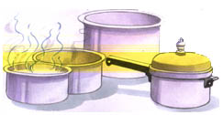
A visible flame touching the sides of vessel wastes fuel since it gives out heat to the surroundings. But if you cover the flame as much as possible by using a broad vessel, you will save fuel. Our tests have established that for most stoves, a vessel of 25 cm. Diameter is ideal for cooking. A vessel of this diameter tends to cover the flame completely. Where a narrower vessel cannot be avoided, try and reduce the flame so that it does not creep up on the sides of the vessel.
Remember
Hide the flame with broad bottomed, vessel. Do not use vessels which are narrow as they allow the flame to creep up on the sides.

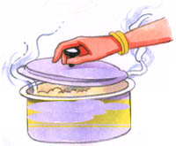 | Put the lid on heat losses
 | It is a good practice to cover cooking vessels and pans with a lid, as an open vessel loses heat to the atmosphere which means a waste of fuel. A vessel of 100sq.cm. opening , containing not water at 96°C would waste 7.2 GMs Of gas per hour. The heat loss would increase by 2-1/2 times if there is wind blowing through the kitchen. If the vessel is covered by a lid , the heat loss would drop appreciably to 1.45 gm. Of gas per hour as heat is retained within the vessel.
Remember
Always place a lid on an open cooking vessel or pan.

The small burner saves fuel | 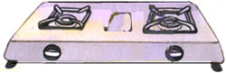
A cooking gas stove has a big burner and a small burner. The small burner consumes 6% to 10% less gas than the big burner ! An experiment on cooking 250 GMs Of potatoes revealed that the small burner consumed 6.5% less gas but look 7 minutes more than the big burner. Similarly in a kerosene stove, by cooking at lower flame you will use less fuel. You can now imagine how much fuel is being avoidably wasted.
True, the small burner of the lower flame takes a little more time to complete cooking, but then you are not always in such a hurry that you can afford to waste fuel.
Remember
Use the small burner or lower flame more often, as the case may be especially when you have time to spare.

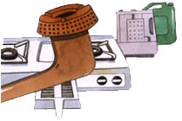 | A clean burner helps save fuel
 | It is important to/clean the burner of your gas range regularly and trim or replace the wicks of the kerosene stove. Soot clogged gas burners and charred wick-ends of a kerosene stove increase fuel consumption. Regular maintenance of your stove helps you save fuel. In case stove knobs do not more freely, get them attended to.
Remember
A bright, steady blue flame means efficient burning. If you see an orange, yellow on non-uniform flame, clean the burner or wick as the case may be.

For additional saving | 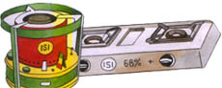
The use of ‘ISI’ marked kerosene wick stoves in place of non-‘IST’ marked stove saves upto 25% of kerosene and the use of higher efficiency ‘ISI’ marked LPG stove (the thermal efficiency level of which is 68%+) saves upto 15% of gas.

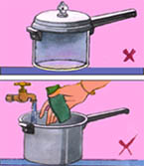 | Clean vessels help too
 | A coating of undissolved salts is usually found on the insides of kettles and cookers. Even a millimeter thick coating can reduce the flow of heat to the vessel’s contents. This increases your fuel consumption by as much as 10%.
Remember
Cooking vessels should always be scrubbed clean.

Allow frozen food to reach room temperature before cooking | 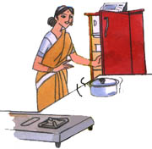
Cold milk, frozen meal or any other cold food-stuff from the refrigerator should not be taken straight to the cooking pot. Keep it out of the refrigerator should not be taken straight to the cooking pot. Keep it out of the refrigerator for some time before putting if on the stove. Very cold food consumes a larger amount of fuel.

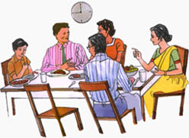 | Plan your meal timings
 | If all members of the family eat together, which signifies togetherness and increases joy, frequent reheating of food before serving can be avoided. If eating together is not possible, store cooked, hot food in insulated containers to serve it hot later.

